On Sunday, January 27, 2019, please join us for a

Parish Bagel Brunch and the Unveiling of our
Iconography Program with Sponsorship Opportunities

Holy Apostle Timotheos of the Seventy
January 23
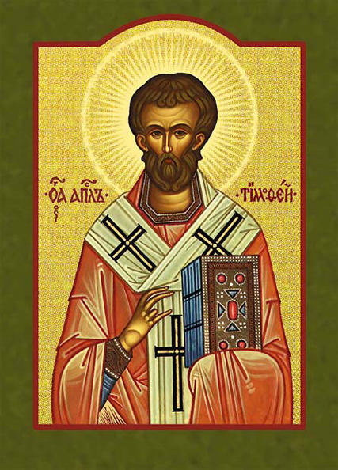
Saint Timotheos (Timothy) was Saint Paul's companion in many of his travels. His mother, Eunice, and his grandmother, Lois, are mentioned as eminent for their piety (II Timothy 1:5) We know nothing of his father, but that he was Greek (Acts 16:1) According to Holy Tradition, Saint Paul ordained Timothy Bishop of Ephesus in 65 AD, where he served for 15 years. When Saint Timothy tried to halt a pagan procession of idols, ceremonies, and songs. In response to his preaching of the Gospel, the angry pagans beat him, dragged him through the streets, and stoned him to death around the year 96 AD. In the 4th century, his holy relics were transferred to the church of the Holy Apostles in Constantinople and buried by the graves of Saint Luke the Evangelist and Saint Andrew the First-Called. The church also numbers Saint Timothy among the 70 Holy Apostles sent out by Jesus Christ to preach the Gospel (St. Luke 10:17) Two epistles of the New Testament were written to him by Saint Paul: I Timothy and II Timothy.

Apolytikion:
Thou didst learn kindness and goodness and wast sober and temperate in all things, and wast clothed with a good conscience as becomes a holy person. Thou didst draw from the Chosen Vessel unspeakable mysteries; and having kept the Faith thou didst finish thy course, O Apostle Timothy. Intercede with Christ our God that our souls may be saved.

