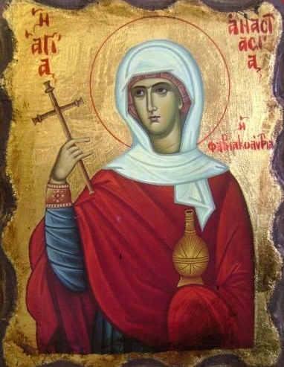
On Sunday, January 13, 2019,
please join us for

The Annual Vasilopita Cutting &
The Unveiling of our Iconography Program with Sponsorship Opportunities

Saint Anastasia Pharmakolitria
Commemorated on December 22
Saint Anastasia was born in Rome into a wealthy family of a pagan father and a Christian mother. She was a beautiful and humble maiden of the early fourth – century. When she was given in marriage to an idol – worshipper, she preserved her virginity by feigning illness. She cared for the imprisoned Christians, encouraging them not to cower before the diverse tortures. When her husband heard this, he had her beaten and forbade her to leave the house or speak to anyone. Saint Anastasia’s teacher, Chrysogonus, foretold that her husband would soon perish at sea, and indeed it happened. When Diocletian heard that the imprisoned Christians were enduring the tortures, he gave orders to kill them all in one night. Chrysogonus was questioned and told to renounce his faith, but when he refused, he was beheaded and thrown into the sea. The waves carried the body and head to shore, and by Divine revelation, the priest Zoilus gathered the relics and concealed them in his home. Zoilus was later martyred. Saint Anastasia encouraged and ministered to three sisters, Agapia, Chionia, and Irene, who were martyred. Saint Anastasia and her helper, Theodota, were imprisoned and persecuted. Following their release, Theodota and her three sons were martyred. Because Saint Anastasia was from a noble Roman family, the magistrate would not torture her. He handed her over to a temple priest who attempted to violate her, but he was suddenly blinded and fell down and died. Saint Anastasia was arrested again, and Theodota appeared to her every night, giving her courage. She was loaded onto a boat with 120 other prisoners and taken out to sea. Soldiers bore holes in the vessel and transferred themselves into another ship. As the vessel began to sink, Theodota appeared and guided it to shore. This miracle caused the pagans on board to believe in Christ, and the 120 men were baptized. They were soon recaptured and beheaded. Saint Anastasia gave up her soul to our Lord in a bonfire.

Saint Anastasia Pharmakolitria is known for her healing abilities and care of the sick and suffering.

Apolytikion – O Lord Jesus, unto Thee Thy lamb doth cry with a great voice: O my Bridegroom, Thee I love; and seeking Thee, I now contest, and with Thy baptism am crucified and buried. I suffer for Thy sake that I may reign with Thee; for Thy sake I die, that I may live in Thee: accept me offered out of longing to Thee as a spotless sacrifice. Lord, save our souls through her intercessions, since Thou art great in mercy.

