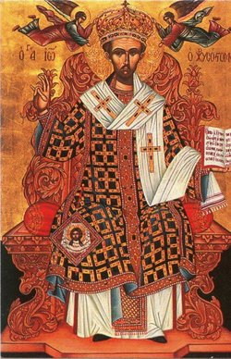
Iconography Committee Featured Icon of the Week
Saint John Chrysostom
Commemorated on November 13
St. John Chrysostomos was born in 347 In Antioch, Syria. His father was a high – ranking military officer named Sekoundos, and his mother Anthousa. Unfortunately, St. John’s mother became a widow early in her life and devoted all her efforts to raising her son. At the age of sixteen St. John was baptized. He attended excellent schools studying Rhetoric and learning about the Christian and Greek wisdom. He was an excellent student and also studied law. St John was very humble and never sought glory and wealth. Therefore, he decided to live ascetically devoting himself to God. When his mother died St. John gave away his wealth, inheritance to the church and poor and traveled to the monastery in the desert and became a monk. An angel appeared to St. John and said to him. “Tomorrow Patriarch Flavian will arrive. He will ask you to accept the priesthood. Do not deny this is Gods will’’. A few days later St. John was ordained a priest. After his ordination he began to preach the word of God to all the faithful. He believed in justice, fought idolatry and always supported the needy. The faithful honored St. John and named him Chrysostomos (golden mouthed) because his words were like gold coming out of his mouth. Later he became the Patriarch of Constantinople. As Patriarch he governed the church for six years with zeal and wisdom. He extended the charitable works of the church, wrote the Divine Liturgy, interpreted Holy Scriptures and many books of his homilies. The people glorified Him, the envious loathed him and Empress Euthoxia sent him to exile. St. John spent three years in exile and reposed in exile on the feast of the Elevation of the Holy Cross on September 14, 407. The Church commemorates St. John Chrysostomos on November 13 the day that his Holy relics were transferred to Constantinople.
Apolytikion - Grace Shining forth from thy mouth like a beacon hath illumined the universe, and disclosed to the world treasures of uncovetousness, and shown us the heights of humility; but while instructing us by the words, O Father John Chrysostom, intercede with the Word, Christ our God, to save our souls.
Kontakion – You received Divine grace from the Heaven and by your own lips taught all of us to worship the one God in Trinity. All blessed, venerable John Chrysostom deservedly, we praise you for you are a teacher clearly revealing things Divine.

