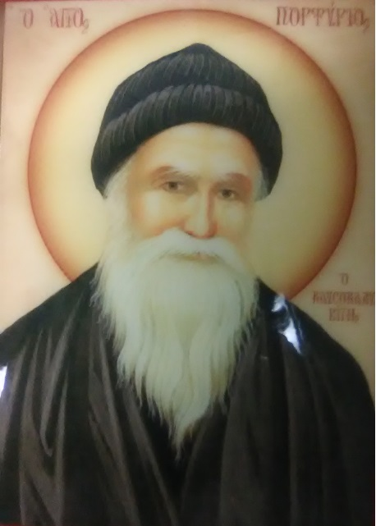
Iconography Committee Featured Icon of the Week
Saint Porphyrios of Kavsokalyva
Commemorated on December 2
St Porphyrios was born on the 7 of February 1906 in the village of Karystia, near Aliveri, in the province of Evia. His parents were poor pious farmers. His father’s name was Leonidas Bairaktaris and his mother’s was Eleni. At Baptism he was given the name Evangelos. He was the fourth of five children. Today only his youngest sister who is a nun is still alive. St. Porphyrios attended school in his village for only two years. The teacher was sick most of the time and the children did not learn much. His father taught him the Paraklisis to Panagia and whatever else of our faith he could. Evangelos left school, worked on the family farm and tended a few animals that they owned. He started working at the age of eight at a coal mine and worked at a grocer’s store in Halkhida and in Piraeus. While looking after the sheep and when working in the grocery store, he would slowly read the story of St. John the Hut Dweller. He wanted to follow the example of the Saint so he set off for Mt. Athos many times, but for many reasons he never made it and returned home. Finally, at the age of fourteen he made it and was tonsured a monk with the monastic name Nikitas. He served in Athonite skete of Kafsokalyvia, in the Cell of St. George, under two spiritual fathers: Father Panteleimon and Father Ionnakios. He gladly gave absolute obedience to both and embraced the monastic life with great zeal. St. Porphyrios would walk barefoot in the snowy paths of the Holy Mountains, would sleep very little on the floor of the hut and during the night would make many prostrations. He immersed himself in the prayers and services of the Church learning them by heart. This young monk was filled with fire for Christ and gave everything for His love. St. Porphyrios acquired supernatural gifts and was vested with power from our Lord. However, severe pleurisy forced him to depart the Holy Mountain, and returned to his birthplace, where he was unexpectedly elevated to the priesthood at the age of twenty-one by Porphyrios III. With the outbreak of World War II he became a hospital chaplain in Athens, from 1940 – 1970. His later years were devoted to the construction of the Holy Convent of the Transfiguration of the Savior. Around 1984 St. Porphyrios returned to Mt. Athos, occupying the same cell which he had earlier in life been forced to abandon. There St. Porphyrios prepared himself spiritually and fell asleep in the Lord on December 2, 1991. As a spiritual father, he became known to an even – wider circle of orthodox followers and was known for his gifts of Spiritual discernment, a type of clairvoyance which he sometimes called “spiritual television.”
We petition St. Porphyrios for the demon possessed and to heal the sick.
Apolytikion –The offspring of Evia, the adornment of Ecimene, the initiated in Theology, and the genuine Friend of Christ, Porphyrios, o faithful, let us honor who was filled with all the gifts of grace from childhood. The demon possessed are redeemed, and the sick are healed who cry out with faith: Glory to Him who gave you might, Glory to Him who sanctified you, Glory to Him who operates through you healing for all.
Kontakion – The most – holy temple of the Paraklete and the most – beloved of all – pure Theotokos, Porphyrios let us praise from our hearts. He loves and heals all and guards and intercedes as we succeed in Theosis. For this let us cry out: Rejoice Father Porphyrios.

