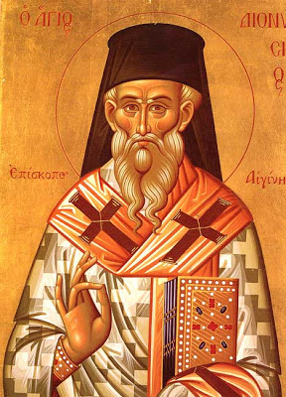
On Sunday, January 13, 2019,
please join us for
The Annual Vasilopita Cutting &
The Unveiling of our Iconography Program with Sponsorship Opportunities

Saint Dionysios of Zakynthos
Commemorated on December 17
St. Dionysios of Zakynthos the Bishop of Aegina was born in 1547 on the Island of Zakynthos. Born into a noble family he was determined to flee the world and set his mind upon heavenly things. He entered the monastery of Strophada and then clothed in the angelic schema. At a very young age he surpassed many of his elders in virtue and was found worthy of ordination to the Holy priesthood. St. Dionysios was then consecrated Bishop of Aegina. He never ceased to teach his flock and many were drawn to him in order to profit from his wisdom. He feared the praise of men so he resigned and returned to Zakynthos. In 1579 St. Dionysios agreed to fill in as bishop of Zakynthos until a new bishop could be elected. He then fled from the worldly life which gave him no peace and went to the monastery of the Most Holy Theotokos Anaphonitria. By God’s will a stranger that murdered the Saint’s brother Constantine sought refuge in the monastery where St. Dionysios was the abbot. When St. Dionysios asked him why he was frightened he confessed his sin and revealed the name of his brother, asking to be protected from the family’s vengeance. St. Dionysios wept for his brother then comforted the murderer and hid him showing him compassion and love. Because of the Saint’s Christ- like virtue, he was granted the gift of working miracles. Having passed his life in holiness St. Dionysios reached an old age then departed to the Lord on December 17, 1624. Not only are the Saint’s relics incorrupt he is also one of Greece’s “Walking Saints”. He is said to leave his reliquary and walk about performing miracles for those who seek his aid.
Saint Dionysios is known as an Areopagite and of forgiveness.
Apolytikion – The faithful son of Zakynthos, Aegina's wise prelate, the protector of the august Monastery of Strophada, O wise Dionysius, with one voice, all we the faithful honour thee and cry: By thy prayers, save them that keep thy memorial and cry unto thee sincerely: Glory to Christ Who hath glorified thee. Glory to Him who hath made thee wondrous. Glory to Him Who made thee our unsleeping intercessor.

