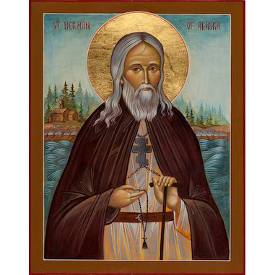
On Sunday, January 13, 2019,
please join us for

The Annual Vasilopita Cutting &
The Unveiling of our Iconography Program with Sponsorship Opportunities

Saint Herman of Alaska
Commemorated on December 13
St. Herman is the first canonized American Saint. St. Herman was born in 1756 to a pious merchant family near Moscow. He entered the monastic life at the age of sixteen and lived at first at the Trinity-St. Sergius Lavra near St. Petersburg, then later at the Valaam Monastery on Lake Ladoga. He often withdrew into the wilderness for days at a time to pray. In 1795, at the age of thirty-eight, he joined seven other monks to travel to America as missionaries. They crossed Siberia, and almost a year later, arrived at Kodiak Island. They found the Aleuts receptive to the teachings of the gospel, and after one year, they had baptized 7,000 people and performed 1,500 marriages. However many of the pagans opposed their message and stirred up the people against them. St. Herman settled on Spruce Island, near Kodiak, and pursued a hermit’s life. He dwelled in a small cabin in the forest and subdued his flesh with great asceticism. He spent his days in prayer and mission work. He slept little, fasted on blackberries and vegetables, wore chains, and a 15 pound cross. He founded an orphanage and a school for natives, built a chapel, and cared for the sick. He became known as the protector of orphans. His kindness, teaching, and the example of his life brought many to Christ, and God granted him prophetic insight and the grace to work miracles. St. Herman dies peacefully on Spruce Island at the age of eighty-one. Some of the inhabitants nearby saw a pillar of light rising above his hermitage. Since his death in 1837, he has been a renowned wonderworker.
St. Herman became known for his spirited defense of the native population against mistreatment by Russian fur traders as well as other missionaries. He is also considered by many Orthodox Christians as the patron saint of North America.

Apolytikion – Blessed ascetic of the northern wilds and gracious intercessor for the whole world, teacher of the Orthodox Faith, good instructor of piety, adornment of Alaska and joy of all America, Holy Father Herman.

